**Spark Application with Java**

**- By Group ‘C’**

**Abhishek Yadav(9180)**

**Gaurav Borse(9182)**

**Sheetal Chauhan(9178)**

**Vaishnavi Dose(9182)**

* First Create project using Spring Initializer.

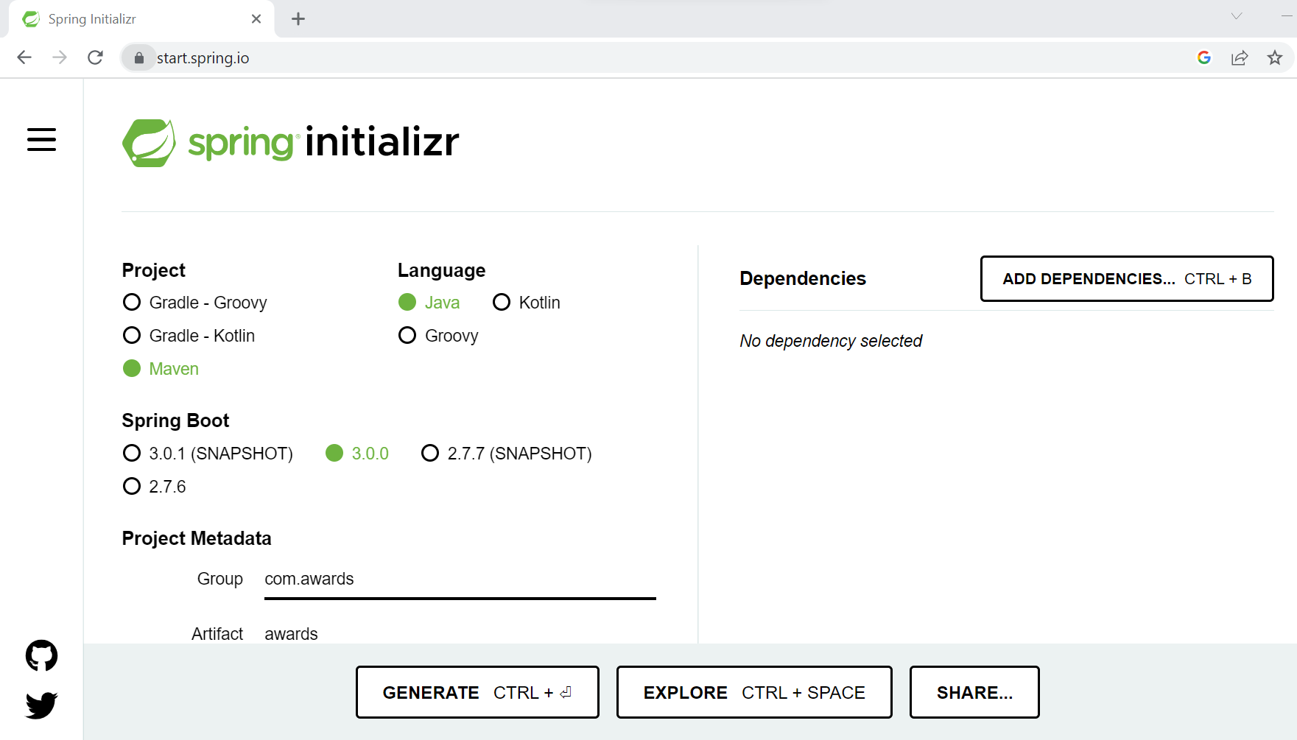

* Then Extract a Zip File.
* Then Import unzip maven project file into Spring tool suite
* Import necessary Dependencies into pom.xml file

1. <dependency> <groupId>org.apache.spark</groupId> <artifactId>spark-core_2.11</artifactId> <version>2.2.1</version> </dependency>
2. <!-- <https://mvnrepository.com/artifact/org.apache.spark/spark-sql> --> <dependency> <groupId>org.apache.spark</groupId> <artifactId>spark-sql_2.11</artifactId> <version>2.2.3</version> <scope>provided</scope> </dependency>
3. <!-- <https://mvnrepository.com/artifact/org.apache.spark/spark-streaming> --> <dependency> <groupId>org.apache.spark</groupId> <artifactId>spark-streaming_2.11</artifactId> <version>2.2.3</version> <scope>provided</scope> </dependency>

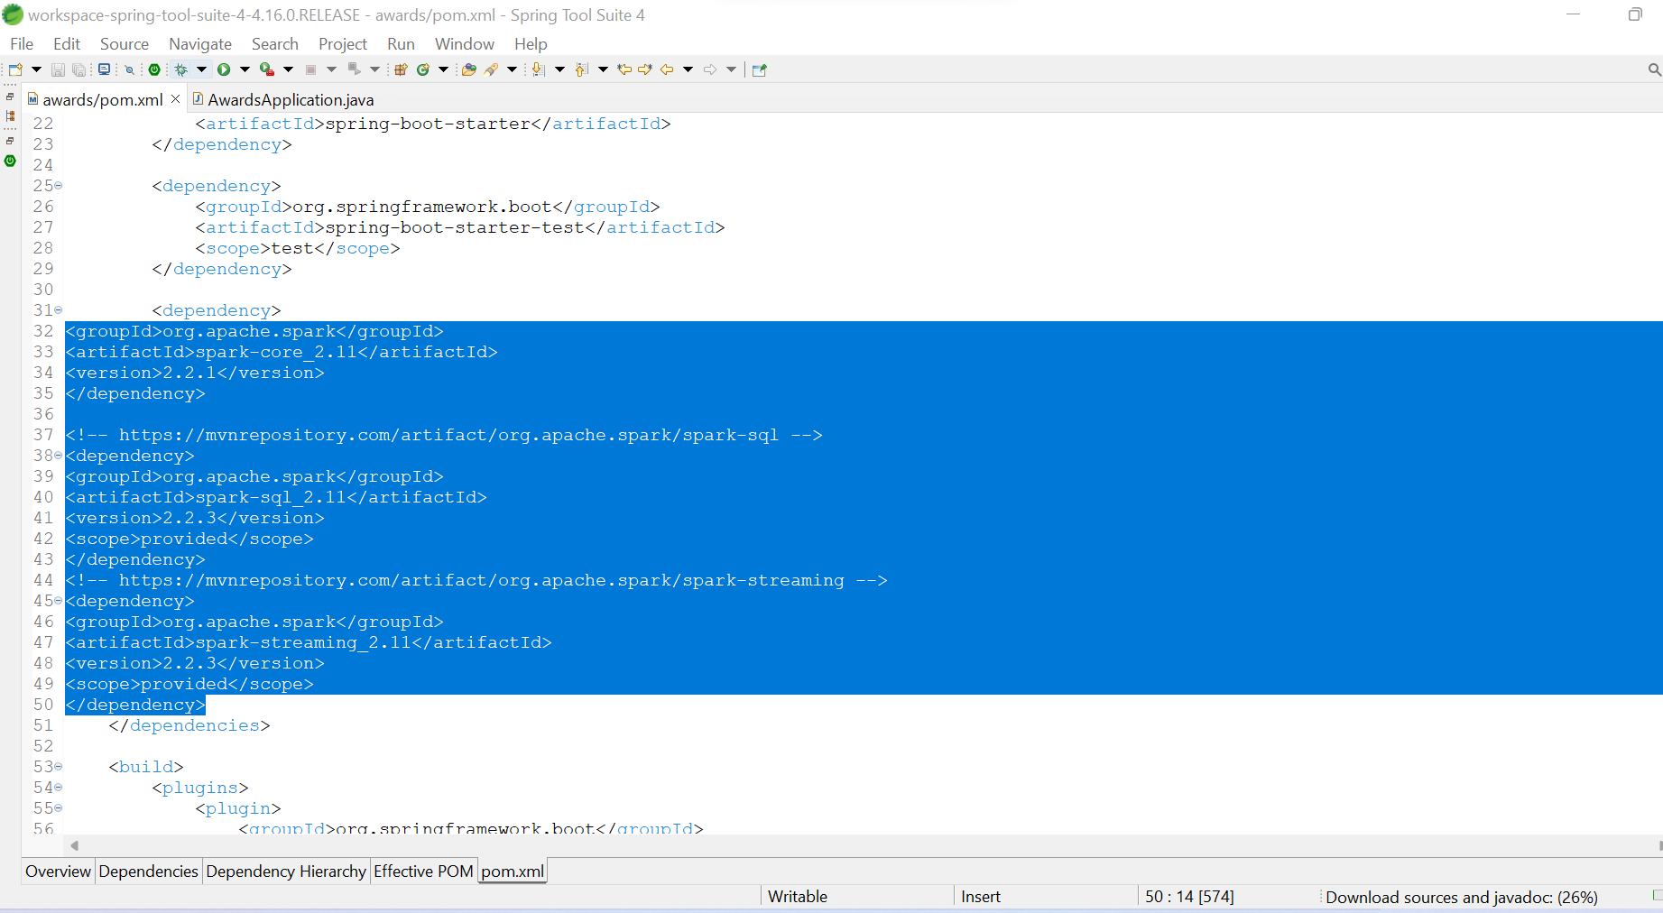

* Now write your java code for spark

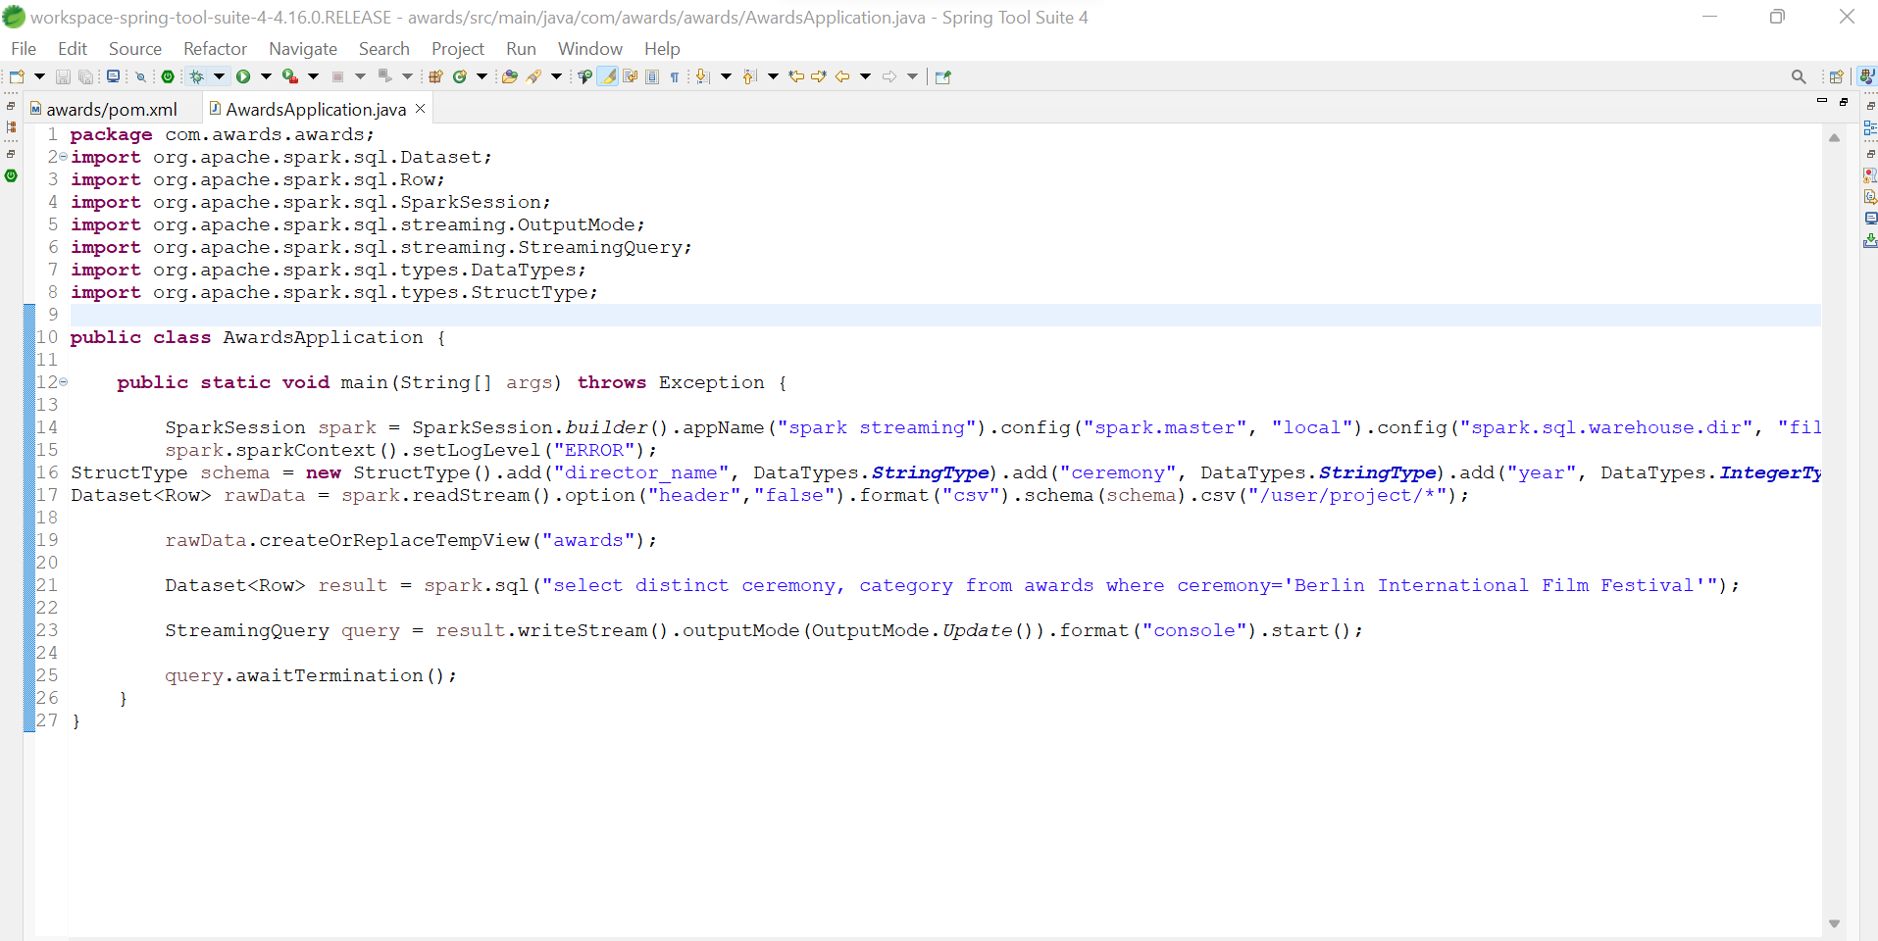

* Now Go to project **awards** right click on it.
* Awards -> export-> java -> jar file

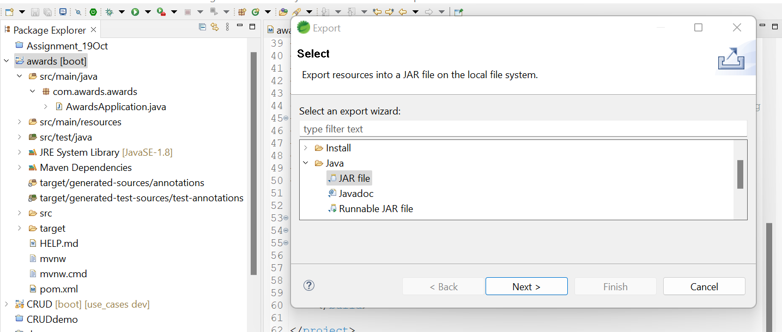

* Click on browser and select file.

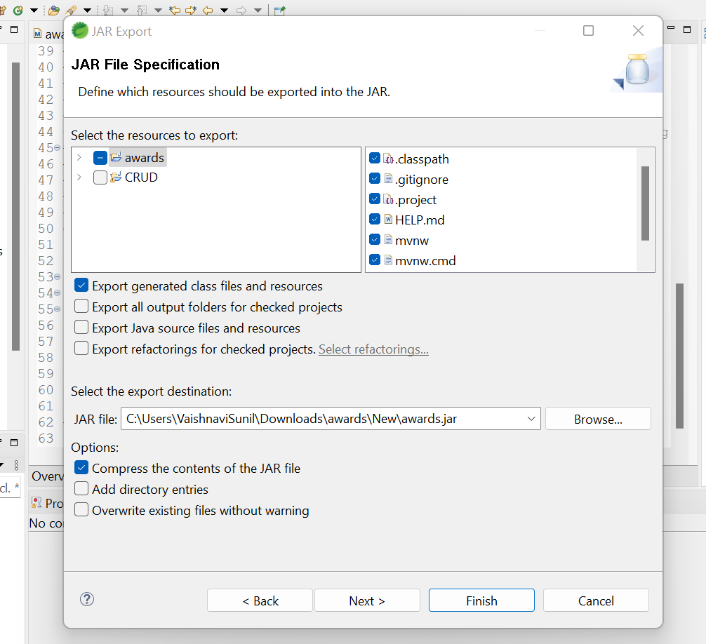

* Click Next then again next .

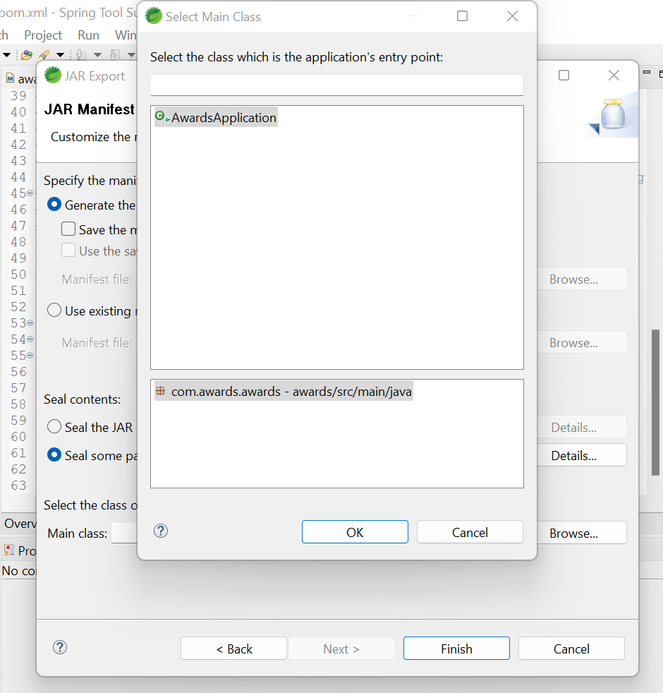

* Then click on browse select AwardsApplication -> ok -> finish.
* Now go to Ambari -> file view -> user -> maria_dev-> datasets

Click on upload and add .jar file from your file explorer.

* Go to HDP location and get your .jar on home directory using thid command.

**hadoop fs –get /user/maria_dev/datasets/awards.jar**

**ls**



For output use this command

**spark-submit --class "com.awards.awards.AwardsApplication" --master yarn --deploy-mode client awards.jar**



**Que.1 Directors who were nominated and have won awards in the year 2011.**

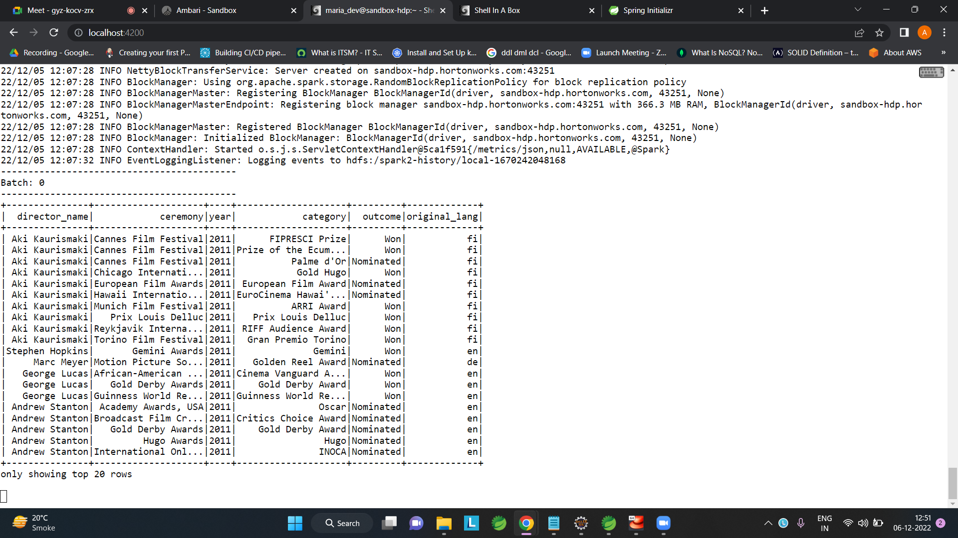

**Que.2 Award categories available in the Berlin International Film Festival.**

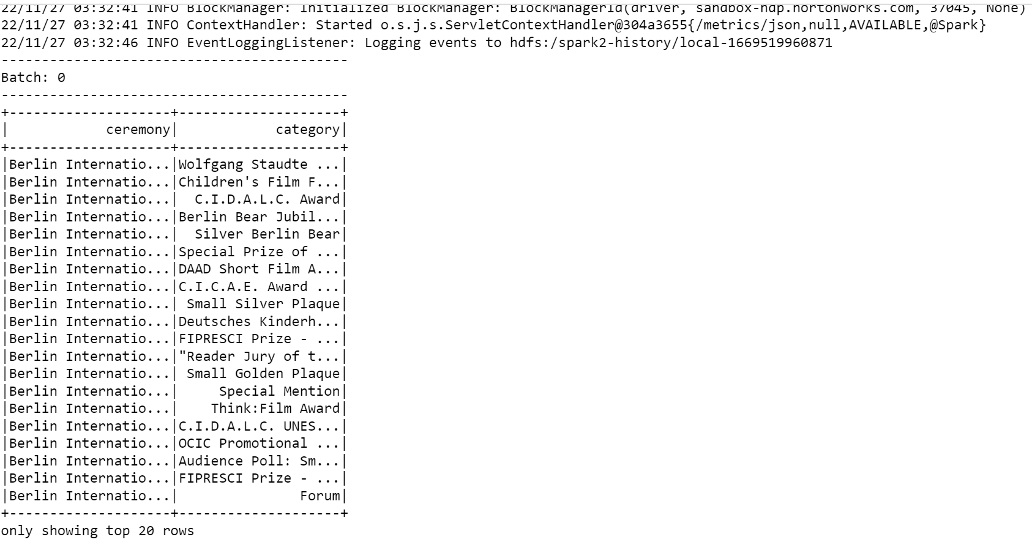

**Que.3 Directors who won awards for making movies in French.**

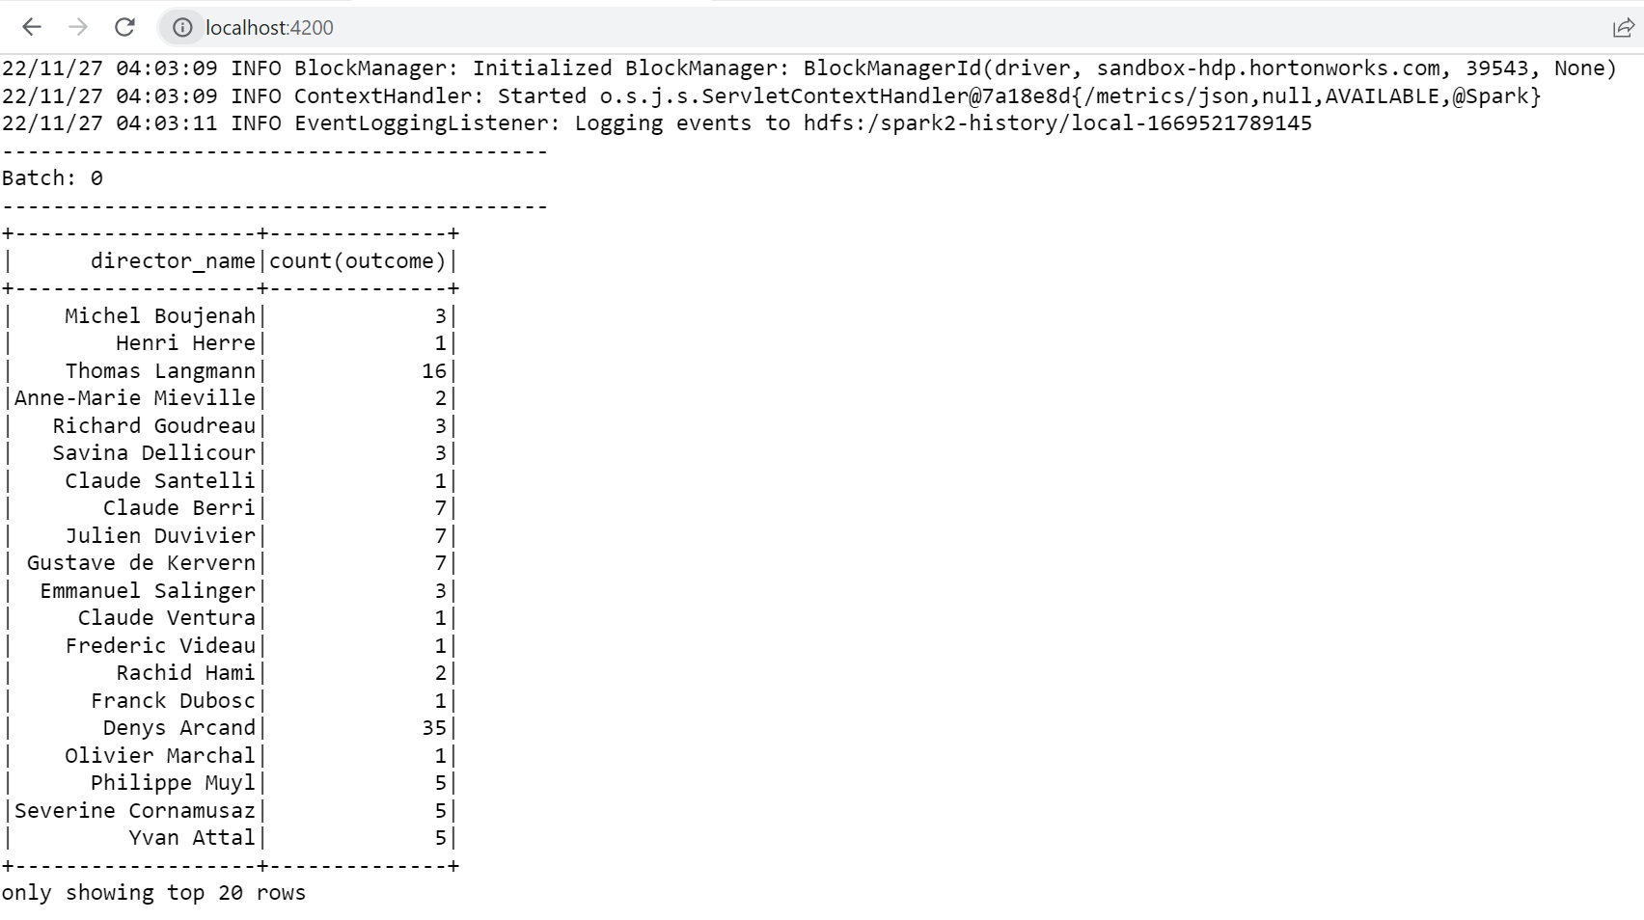

**Que.4 Directors who have won awards more than 10 times.**

